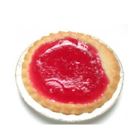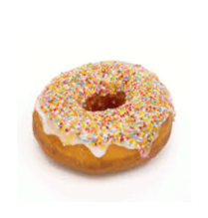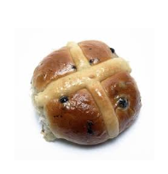

Bun: 8p

Doughnut: 20p £12

Tart: 15p

|  |  |  |  |
| --- | --- | --- | --- |
| Question | Bar | Number sentence | Answer |
|  |  |  |  |
|  |  |  |  |
|  |  |  |  |